**Indian Institute of Technology Bombay**

**DEPARTMENT OF METALLURGICAL ENGINEERING & MATERIALS SCIENCE**

**MM 204 Transport Phenomena : 2018-19 : Spring**

**Tutorial 4 Jan 30, 2019**

1. 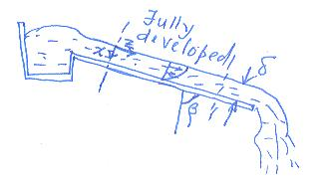Water is flowing freely as a film down a wide inclined plane. The thickness of the water film is small compared to its width. Perform a shell balance for the fully developed flow regime of the film of water (away from the edge plates) and get an expression for the velocity as a function of x. List assumptions.



Note that at the free water surface (x=0), shear stress exerted by air above is negligible. Further all along the top surface pressure is atmospheric. If you neglect static pressure variation in air (density small compared to that of water), pressure is constant along the surface. In the x-direction there is no flow and you expect the pressure to vary as static pressure. Then ∂p/∂z = 0. The driving force for flow is gravity alone.

δ



1. Liquid steel in an open cylindrical ladle 3 m in diameter discharges into the atmosphere through a *short* nozzle of 50 mm, placed at the bottom.

*h*

1. Calculate initial rate of discharge of steel, if the height *h* of water in the tank above the nozzle is 7.5 m. Friction can be neglected as a first approximation.
2. As the liquid flows out, the level in the tank falls decreasing the discharge rate. Calculate the time required for the level to fall to 3.1 m.
3. If now the friction cannot be neglected, and the frictional loss term for the nozzle is ${\hat{W}}_{fr}=0.2*{(\overline{V}}_{2}^{2}/2)$, J/kg, what is the initial flow rate of steel ?

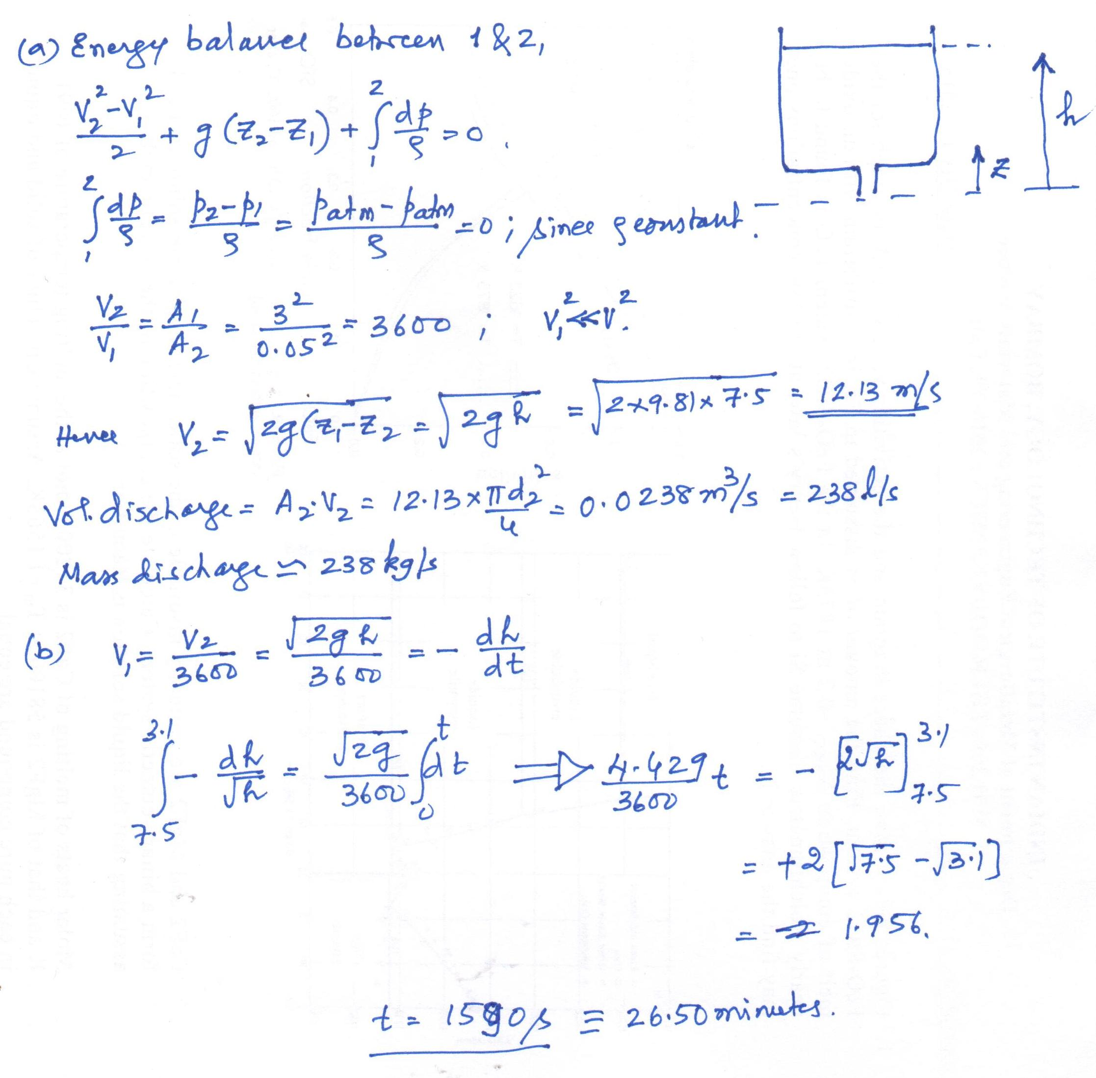

1. Now the energy balance equation becomes:

$\frac{V_{2}^{2}-V_{1}^{2}}{2}+g \left(z_{2}-z_{1}\right)+ \frac{p_{2}-p_{1}}{ρ}+{ \hat{W}}_{fr}=0$**;**

$\frac{V_{2}^{2}}{2}+g \left(z_{2}-z_{1}\right)+ \frac{p_{2}-p_{1}}{ρ}+ 0.2\frac{V_{2}^{2}}{2} =0$**;**

$\frac{V_{2}^{2}}{2}(0.8)+g \left(z_{2}-z_{1}\right)+ \frac{p_{2}-p_{1}}{ρ}=0$**;**

$$Proceed now as in (a)$$